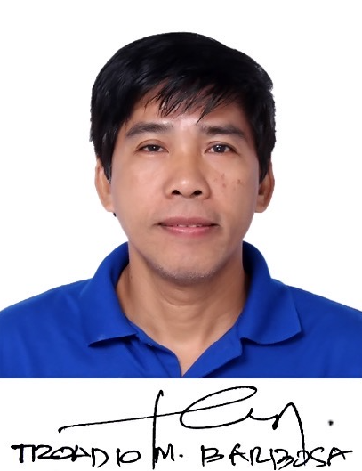
Curriculum Vitae of

TROADIO MOISES BARBOSA
#225 Upper Kolambog Lapasan
9000 Cagayan de Oro City, Philippines
Contact no. (+63)0 9171279568
Email Address: troadio.barbosa@ustp.edu.ph

EDUCATIONAL BACKGROUND

Graduate: Master in Technician Teacher Education (MTTE) (Graduate) 2022
University of Science and Technology of Southern Philippines
Cagayan de Oro City, Philippines

Master of Technology (candidate) 2011
Technological University of the Philippines
Manila, Philippines

COLLEGE
School: Guzman Institute of Technology
Course: Bachelor of Science in Industrial Education
Major: Electronics
Address: Manila
College: Bachelor of Science in Industrial Education (Graduate) 1997
Major in Electronics
Guzman college of Science and Technology –formerly GUZMAN INST. OF
TECH Quiapo - Manila, Philippines
VOCATIONAL
School: Guzman Institute of Technology
Course: Electronics Technology 1993
Major: Electronics
Address: Quiapo - Manila, Philippines

PROFESSIONAL WORK BACKGROUND

June 2017 to Full-time Instructor, College of Technology Department

present University of Science and Technology of Southern Philippines (USTP)
Claro M. Recto Ave., Cagayan de Oro City, Philippines

June 1997 to Part-time Instructor, Information Technology Department

2017 Mindanao University of Science and Technology
Claro M. Recto Ave., Cagayan de Oro City, Philippines

May 1999 to Regular Instructor, Electronics and Computer Tech. Dept.

June 30, 2011 Asian College of Science and Technology (ACSAT)
Luna – Velez Sts.., Cagayan de Oro City

Jan 1998 to Casual Instructor, Electronics and Computer Tech. Dept.

May 1999 Asian College of Science and Technology (ACSAT)
Cubao Quezon City

INDUSTRY EXPERIENCE

March 1993 to Electronics Technician
Sept 1993 MACLIN ELECTRONICS INCORPORATED

Quezon City, Philippines

Sept.4, 1998 to Faculty Immersion Program
Sept.6, 1998 Data General Philippines Semiconductor
Cubao Quezon City, Philippines

SKILLS

Computer Related
-Networking (Microsoft windows Network, Peer to Peer, Server based Net.
-Software application (MS Excel, MS word, MS Power Point, Suns Star
office)
-Programming
Turbo C
Internet
- Website design

Static HTML

Computer Encoding (Typing)
- PIC Microcontroller (Peripheral Interface Controller) Programming

Industrial
- Pneumatics, Electropneumatics, Hydraulics,
- Mechatronix
- Programmable Logic Control
- Computer Interfacing (Arduino, Raspberrypi)
- Computer Hardware Servicing

INTERESTS

ROBOTICS
PIC microcontroller, PLC, Arduino, Raspberrypi, Industrial and Academic Training,

ELIGIBILITY/GOVERNMENT EXAMINATIONS

Computer System Servicing NCII (TESDA)
Cagayan de Oro City
6/28/2024 to 6/27/2029

Electronic Product Assembly NCII (TESDA)
Cagayan de Oro City
6/28/2024 to 6/27/2029

Accredited Competency Assessor (AQ 1) in Computer Hard. Servicing (NCII)
October 7, 2007 to October 7, 2012 (TESDA)

National TVET Trainors Level 1 (TQ 1) (TESDA)
Cagayan de Oro City
November 11, 2011

Consumer Electronics Mechanic NC1 (TESDA)
1998
Manila

HONORS/AWARD RECEIVED

March 30, 1997 Academic Excellence Award (Guzman Institute of Technology)
Quiapo Manila
December 2001 Best Instructor of Electronics and Computer Technology, Acsat Cagayan de Oro City
April 2010 Loyalty Award (Acsat Cubao Quezon City)

TRAININGS, SEMINARS AND CONFERENCES ATTENDED

CONFERENCE ATTENDED
1ST REGIONAL RESEARCH AND INNOVATION SUMMIT (presenter) (November 2023)

AS TRAINOR
ROBOTICS and Intelligent Machines Training Held at USTP-cdo
January 13, 27, Feb 17 and 24, 2024

MINDANAO STATE UNIVERSITY – ILIGAN
COACH IN 7th Iligan Computing Fair – Computer Hardware Servicing
November 24-25, 2009 – first Runner Up

MINDANAO UNIVERSITY OF SCIENCE AND TECHNOLOGY
SEMINAR/WORKSHOP Trainor in Computer and Technical Skills for MUST Non- Teaching Personnel
August 9,and 23, 2014 (16hrs)

MINDANAO UNIVERSITY OF SCIENCE AND TECHNOLOGY
SEMINAR/WORKSHOP Trainor in Computer Enhancement Training for MISOR Barangay Officials
Oct. 19, 2015 to Oct. 23, 2015 (40HRS)

RESEARCH PROJECTS CONDUCTED

Securing Campus Resources: Smart Locker System with Student ID Authentication in University Setting (published June 2025)

Innovated Four-Stroke Gasoline Engine Trainer for Grade 12 Senior HS Students
(Published July 2025)

Securing Campus Resources: Smart Locker System with Student ID Authentication in University Setting (published June 2025)

Design and Evaluation of a Multimeter Model for a Wider View in a Classroom Setting (published 2022)

